MARS AVATAR PROJECT — Control Without Presence
Concept White Paper, v3.5 (full edition, revised)
Oleksandr Khalanhot · Independent researcher · Zürich, Switzerland · mars-avatar.com
July 2026

Table of Contents

Executive Summary 3
Chapter 1. Introduction 4
Chapter 2. The Challenge of Exploring Mars 6
Chapter 3. Positioning Relative to Existing Work 9
Chapter 4. The Mars Avatar Project Architecture 12
Chapter 5. Artificial Intelligence as the Core of the System 15
Chapter 6. Mission AI Architecture 21
Chapter 7. Interplanetary Communication and Mission Control 25
Chapter 8. Robotic Avatars 29
Chapter 9. The Human–Machine Interface 35
Chapter 10. Technology Roadmap 38
Chapter 11. Quantitative Estimates 41
Chapter 12. Analysis of Risks, Limitations, and Ethical Aspects 46
Chapter 13. Conclusion and Prospects 49
Appendix A. References and Literature 52
Appendix B. Note on Neural Interfaces 56

Executive Summary
The Mars Avatar Project (MAP) is a conceptual architecture for exploring Mars in which humans retain full intellectual control from Earth while a fleet of specialized robotic avatars provides physical presence on the surface. The one-way signal delay of 4–22 minutes is treated not as an obstacle but as a design condition: the operator transmits goals, and onboard autonomy determines how to achieve them.
The contribution. Nearly every component of this architecture has already been demonstrated in isolation — goal-based commanding on NASA rovers (AutoNav, AEGIS), supervisory telepresence from orbit (ESA METERON), immersive avatar interfaces (ANA Avatar XPRIZE). What no program has built is the layer that coordinates a heterogeneous fleet under full interplanetary latency. That layer — Mission AI — is the project’s principal original contribution: a five-layer reference architecture, a formal goal-package protocol, graduated decision classes (A/B/C) with a controllable trajectory of increasing autonomy, and measurable quality metrics (Chapter 6).
The economics. A Stage III fleet of ten specialized platforms plus two orbital relays is estimated at ≈ $18–31B over a ten-year operating cycle, against ≥ $100B for the lower bound of a crewed program — while fitting within the proven ≤1 t entry-descent-landing envelope that crewed architectures exceed by an order of magnitude (Chapter 11). The cancellation of Mars Sample Return after its estimate grew to ~$11B illustrates the cost of return architectures; MAP avoids them by design — avatars do not return.
The asset. Unlike an expedition, the architecture is a transferable technology: moving from Mars to the Moon, Europa, Titan, or an asteroid changes parameters (delay, gravity, environment), not principles. Mars is not the destination; it is the first and most instructive proving ground. A system that works under a 22-minute delay will work anywhere (Chapter 13).
The principal open problem. Neither this architecture nor any foreseeable one removes the boundary of the modelled fault space: onboard systems handle the contingencies that were anticipated, and present-day AI does not meaningfully extend that set. What a coordinated fleet changes is the consequence of reaching that boundary — from the loss of a mission to the reallocation of a task (Section 5.13). This is a narrower claim than autonomy advocacy usually makes, and it is the one this document defends.

Chapter 1. Introduction

1.1 Introduction
Humanity is entering a new era of space exploration. Over recent decades, robotic missions have significantly expanded our knowledge of the Solar System, and automated spacecraft have proven their effectiveness in studying the Moon, Mars, asteroids, and other celestial bodies. Despite these successes, crewed expeditions beyond near-Earth space remain extremely difficult. Prolonged flights require protecting the crew from cosmic radiation, building reliable life-support systems, solving the medical problems of long-term weightlessness, and ensuring a safe return to Earth. These factors substantially increase the cost, complexity, and risk of such missions. At the same time, robotics, artificial intelligence, computer vision, autonomous navigation, and human–machine interfaces are developing rapidly. The combination of these technologies opens the possibility of considering a different approach to planetary exploration. This document presents the concept of the Mars Avatar Project — an architecture in which the human retains key decision-making while intelligent robotic avatars provide physical presence on the surface of Mars. In such a system, autonomous algorithms compensate for the unavoidable communication delay between Earth and Mars, performing local actions within the goals set by the operator. It is important to emphasize that this document is not the design of a ready-made space mission. It is a conceptual study whose aim is to propose a coherent roadmap for developing the technologies required for such an architecture. The work deliberately distinguishes among:
- existing technologies;
- projected directions of development;
- long-term research hypotheses.
This approach makes it possible to discuss the idea in an engineering context without conflating the confirmed capabilities of present-day technology with more distant scientific prospects.

1.2 Purpose of the Document
The purpose of this White Paper is to present a conceptual architecture for a telepresence system for exploring Mars, integrating advances in robotics, artificial intelligence, space communication, and human–machine interfaces. The document seeks to answer the following questions:
- Which technologies already make it possible to implement individual elements of such a system?
- Which engineering problems remain unsolved?
- What might a realistic path for developing such technologies over the coming decades look like?
- What are the advantages and limitations of an approach based on robotic avatars?

1.3 Scope of Application
The proposed architecture may be considered for a variety of scenarios:
- scientific study of the Martian surface;
- construction of automated infrastructure;
- preparation for future crewed missions;
- equipment servicing;
- resource extraction;
- exploration of other planets, moons, and asteroids.

1.4 Mission versus Technology
The key distinction underlying this document is the distinction between a mission and a technology. A crewed expedition is a mission: enormous resources are spent to deliver specific people to a specific place and bring them back. The result of an expedition cannot be reused — every subsequent flight requires nearly the same expenditure as the previous one. The history of Mars Sample Return demonstrated this in miniature: it was precisely the return architecture (ascent from Mars, orbital rendezvous) that became the principal driver of cost growth from ~$3–4B to ~$11B and the reason for the program’s cancellation [22]. A telepresence architecture is a technology: once created, the loop of “goal → autonomous execution → report” is a transferable asset. In moving from Mars to the Moon, Europa, Titan, or an asteroid, only the parameters change — the magnitude of the signal delay, gravity, the properties of the environment. The architecture itself — Mission AI, the goal-package protocol, the decision categories, the degradation hierarchy — remains unchanged. The question of this document is therefore framed not as “how to reach Mars” but as “how to build a universal technology of presence.” In this framing, Mars is not the goal but the first and most instructive proving ground: a planet of maximal scientific return, with a communication delay large enough to test the architecture honestly. A system that works under a 22-minute delay will work anywhere.

Chapter 2. The Challenge of Exploring Mars

2.1 Why Mars?
Mars remains one of the most attractive targets for human exploration. Compared with other objects in the Solar System, it offers a number of advantages: a day length close to Earth’s, the presence of an atmosphere (albeit very thin), reserves of water ice, and significant scientific potential. Studying Mars can help answer fundamental questions about the origin of planets, the evolution of climate, and the possibility of life beyond Earth. In addition, the experience gained may become the basis for future expeditions to more distant objects in the Solar System. However, Mars remains an extremely difficult environment for human work.

2.2 Principal Engineering Challenges

Cosmic Radiation
Beyond Earth’s magnetic field, the crew is exposed to galactic cosmic rays and solar energetic particles. Even with modern protective measures, prolonged stays in interplanetary space increase health risks, including the likelihood of developing cancers, nervous-system damage, and other long-term consequences [1][2][3]. For robotic systems this problem is far less critical, since they require no biological shielding and can be designed with radiation-hardened electronics.

Mission Duration
A typical crewed expedition to Mars may last more than two years, accounting for the flight, the wait for a favorable return window, and the journey back. Throughout this time it is necessary to provide:
- food;
- water;
- oxygen;
- medical care;
- psychological support;
- maintenance of life-support systems.
Each additional day increases the complexity of the mission.

Limited Human Capabilities
Even after a successful landing, a human faces serious limitations:
- fatigue;
- the need for rest;
- limited duration of extravehicular activity;
- the effects of reduced gravity;
- the risk of errors under high workload.
Robotic systems also have limitations, but they can operate far longer without breaks, provided they are supplied with power and maintenance.

2.3 Communication Delay
One of the key engineering problems is the distance between Earth and Mars. Depending on the relative positions of the planets, a signal takes roughly 4–22 minutes one way [4][5]. The physical minimum at closest approach is close to 3 minutes; 4 minutes is used throughout this document as a conservative working value. Direct real-time control of a robot is therefore impossible. For example:
- the operator presses a button;
- the command reaches Mars after several minutes;
- the robot performs the action;
- confirmation returns after several more minutes.
The full cycle can take tens of minutes. Consequently, the traditional teleoperation model is not suitable for interplanetary missions.

2.4 Why Is Simply Increasing Communication Speed Not Enough?
No advance in data-transmission technology can remove the fundamental limitation associated with the speed at which electromagnetic waves propagate. Even ideal communication is limited by the speed of light. Consequently, the architecture of future systems must treat the unavoidable delay as a basic physical condition rather than a temporary technical problem. This leads to the necessity of using autonomous algorithms capable of performing local actions without constant human involvement.

2.5 The Cost of Crewed Missions
Crewed expeditions require complex systems:
- heavy launch vehicles;
- landing modules;
- habitation modules;
- resource reserves;
- crew-protection systems;
- return vehicles.
Each of these components substantially increases the cost of the program. Robotic missions also require significant investment; however, they need no life-support systems and can be specialized for particular tasks, which potentially allows the infrastructure to be scaled more flexibly.

2.6 Problem Statement
Given the limitations listed above, a question arises: Is it possible to create a system in which the human retains intellectual control of the exploration while physical presence on the surface is provided by a network of autonomous robotic avatars? This document treats this idea as a conceptual architecture that combines modern advances in robotics, artificial intelligence, and space communication. The goal is not to replace future crewed missions but to explore whether such an approach can complement them, improving the safety, flexibility, and effectiveness of Mars exploration.

Chapter 3. Positioning Relative to Existing Work
A concept earns credibility not by claiming novelty, but by showing precisely where it stands among its predecessors.

3.1 Why This Chapter Is Needed
The idea of commanding remote robots at the level of goals rather than individual movements is not new. Several elements of the Mars Avatar Project architecture have already been demonstrated in operational NASA and ESA missions, in orbital experiments, and in ground-based telepresence competitions. The absence of an honest comparison with this prior work is a characteristic weakness of visionary documents, and it undermines the trust of a technical audience. The purpose of this chapter is to show which components of the concept have already been validated in practice, by which programs, and what precisely distinguishes the contribution of the Mars Avatar Project.

3.2 Goal-Based Commanding in Operational Mars Missions
Control of NASA’s Mars rovers has, from the outset, relied not on teleoperation but on daily command packages: operators build a plan for the sol, the rover executes it autonomously, and results return to Earth in time for the next planning cycle. The AutoNav system on the Perseverance rover extended this model to autonomous route selection: as shown later in Chapter 5, roughly 88% of the traverse was completed without direct operator involvement [8][9]. In addition, the AEGIS system running on Curiosity and Perseverance autonomously selects science targets for spectrometers without waiting for commands from Earth [28]. The principle “goal → autonomous execution → report” is therefore not a hypothesis but operational practice in planetary missions. The Mars Avatar Project extends it from a single vehicle to a coordinated fleet.

3.3 ESA METERON and the Analog-1 Experiment
The closest experimental predecessor is the ESA METERON program (Multi-Purpose End-To-End Robotic Operation Network, 2011–2019), in which astronauts aboard the ISS controlled robots on the ground, modeling a “crew in orbit — robots on the planet’s surface” scenario.
- Kontur-2 (a DLR/Roscosmos experiment conducted alongside METERON) and Haptics-1/2 — experiments with force-feedback (haptic) control over an orbital communication link.
- SUPVIS Justin (2017–2018) — supervisory control of the humanoid robot Justin (DLR): the astronaut set goal-level tasks through a tablet interface, and the robot executed them autonomously [17].
- Analog-1 (November 2019) — astronaut Luca Parmitano, aboard the ISS, controlled the Interact rover at a test site in the Netherlands, including soil sampling with haptic feedback [15][16].
METERON experimentally confirmed key elements of telepresence, but in a low-latency scenario (orbit-to-surface, fractions of a second). The Mars Avatar Project addresses the opposite regime: the operator remains on Earth, the delay is measured in minutes and is compensated by autonomy rather than by a real-time link.

3.4 NASA HERRO and Low-Latency Telerobotics
The HERRO concept (Human Exploration using Real-time Robotic Operations, NASA Glenn Research Center, ~2009–2011) proposed sending a crew to Mars orbit without landing: astronauts would control surface robots in near-real time, avoiding the risk and cost of landing and ascent [18]. A related line of work is “low-latency telerobotics” research (Lester, Thronson, and others), which treats latency as the dominant factor in the effectiveness of remote work [19]. In 2013, NASA conducted the Surface Telerobotics experiment: astronauts aboard the ISS controlled the K10 rover at Ames Research Center, modeling the operation of a lunar rover from a cislunar station [20].
The fundamental distinction of the Mars Avatar Project: HERRO buys low latency at the price of a crewed interplanetary transit — that is, it retains most of the problems listed in Chapter 2 (radiation, life support, cost). MAP makes the opposite wager: eliminate human transit entirely, accept high latency as a design condition, and close it with autonomy. The two approaches are complementary rather than mutually exclusive: the MAP architecture is compatible with a later addition of an orbital crew as a “near” control layer.

3.5 ANA Avatar XPRIZE and Ground-Based Telepresence
The ANA Avatar XPRIZE competition (2018–2022, a $10 million prize purse) demonstrated the maturity of ground-based avatar systems: teams built robots through which a remote operator could see, hear, move, and manipulate objects; the winner was Team NimbRo of the University of Bonn [21]. The competition confirmed the technical feasibility of immersive interfaces (Chapter 9), but under latency of tens of milliseconds. Its results apply to Stage I of the MAP roadmap (ground demonstrations) but do not transfer directly to the interplanetary case — which further underscores the need for an autonomous layer.

3.6 Commercial Space Robotics
The private sector is actively developing orbital and planetary robotics: GITAI has demonstrated autonomous manipulators inside (2021) and outside (2024) the ISS and is developing lunar robotic platforms [30]. On the landing side, Intuitive Machines performed the first commercial soft landing on the Moon (IM-1, February 2024) and Firefly Aerospace the first fully successful one (Blue Ghost, March 2025), while Astrobotic’s Peregrine (January 2024) was lost to a propulsion failure before a landing attempt could be made. This means that part of the MAP hardware base can be built through commercial cooperation rather than by agencies alone — and equally, that the reliability assumptions of Section 8.10 must be drawn from a record that includes failures as well as successes.

3.7 Positioning Table
Program / Project | What Was Demonstrated | Latency Regime | MAP’s Distinction
NASA rover operations (MER, MSL, Mars 2020) + AutoNav, AEGIS | Goal-based commanding, autonomous navigation and target selection on Mars | Minutes (signal); sol-length planning cycle | Fleet of heterogeneous platforms rather than a single vehicle; construction tasks
ESA METERON / Analog-1 | Supervisory control and haptic link from orbit | Fractions of a second | Operator on Earth; autonomy instead of a real-time link
NASA HERRO, Surface Telerobotics | Concept and experiment in teleoperation from orbit | Fractions of a second – seconds | No crewed transit; latency as a design condition
ANA Avatar XPRIZE | Immersive avatars, manipulation, telepresence | Tens of milliseconds | Interplanetary latency; goal-based rather than motor control
GITAI, commercial lunar missions | Autonomous manipulators in space, landing platforms | Seconds (Moon) | Possible hardware base; MAP adds fleet coordination

3.8 Statement of Contribution (Novelty Claim)
The comparison shows that nearly every component of the Mars Avatar Project has already been demonstrated in isolation. The concept’s contribution is therefore framed not as the invention of new components but as their system integration:
- an architecture for goal-based control of a heterogeneous fleet of specialized platforms from Earth under full interplanetary latency — unlike single rovers and orbital scenarios;
- Mission AI as a coordination layer between the operator and the fleet (detailed in Chapter 6), whereas existing missions are autonomous only at the level of an individual vehicle;
- the objective function of “building infrastructure for future crewed missions,” not merely scientific observation;
- a staged verification roadmap Earth → Moon → Mars with explicit transition criteria (Chapter 10).
Multi-robot coordination under a single intelligent dispatcher is precisely the least-developed area in current programs — and this is the principal space for the project’s original contribution.

Chapter 4. The Mars Avatar Project Architecture

4.1 General Concept
The Mars Avatar Project is based on the principle of “Control Without Presence” — control without physical presence. Unlike the traditional model of crewed expeditions, where the human personally performs all actions on the planet’s surface, the proposed architecture separates intellectual and physical presence. The human remains the source of goals, decisions, and scientific analysis, while the robotic system provides direct interaction with the environment. Thus, intelligence remains on Earth, while physical presence is transferred to Mars via autonomous robotic platforms.

4.2 System Architecture
The concept comprises six interconnected functional layers — described in Sections 4.3–4.8 and grouped into three segments (Earth, space link, Mars) in the diagram below.
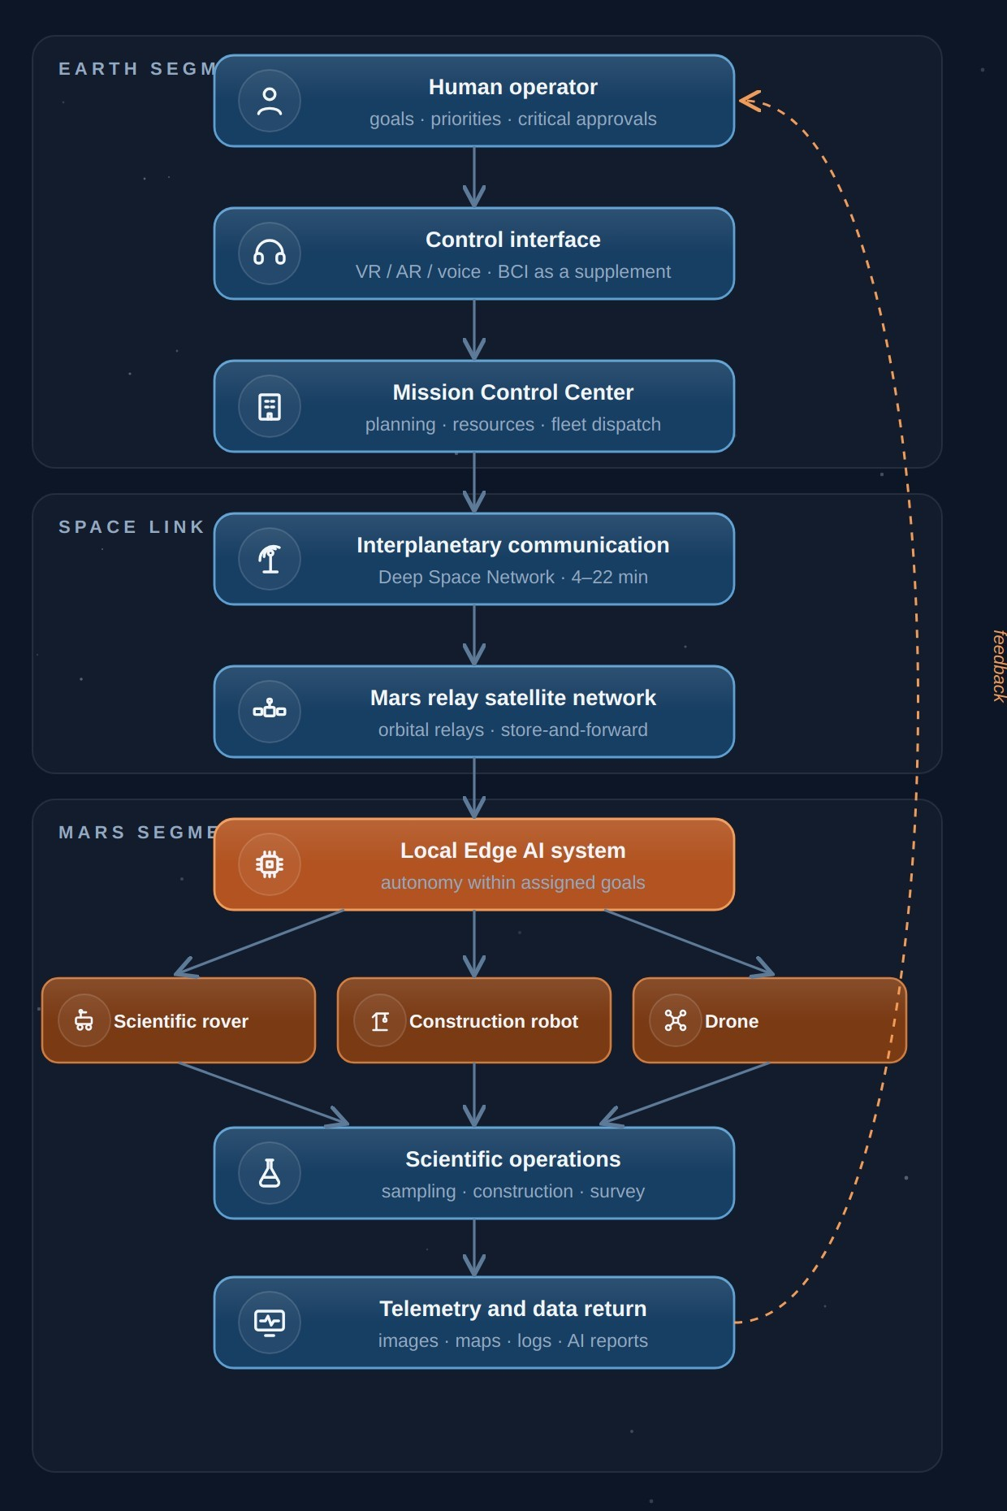 | Fig. 4.1. Architectural diagram of the Mars Avatar Project system

4.3 The Human Layer
The human remains the central element of the entire system. The human:
- defines the scientific tasks;
- sets priorities;
- approves critical decisions;
- analyzes the results obtained;
- intervenes in non-standard situations.
The AI does not make strategic decisions on its own.

4.4 The Control Interface
In the early stages, traditional means are used: computer, VR, AR, joysticks, voice control. As technology develops, brain–computer interfaces (BCI) may be used, allowing faster and more convenient interaction with the system. It is important to note that in the near term BCI is regarded as a supplement, not a mandatory component.

4.5 The Mission Control Center
Mission Control unifies all elements of the system. Its functions:
- task planning;
- priority management;
- resource allocation;
- control of multiple avatars;
- processing of scientific information;
- interaction with operators.
In effect, it is the intelligent dispatcher of the entire expedition.

4.6 Interplanetary Communication
Information is transmitted through existing or future deep-space communication networks. Its main functions: transmission of commands and telemetry, synchronization of system state, verification of data integrity, and encryption. The architecture envisions the use of relay satellites in Mars orbit to improve communication reliability [6][7].

4.7 The Local Artificial Intelligence
This is the key element of the entire concept. Because of the signal delay, it is the local AI that makes decisions within the assigned task. For example, the operator sends the command: “Collect a rock sample near the crater.” The AI then, on its own:
- plans a route;
- avoids obstacles;
- monitors the robot’s stability;
- selects the sampling location;
- assesses safety;
- performs the manipulation;
- returns a report to the operator.
The human defines the goal. The AI determines how to achieve it within the given constraints.

4.8 Robotic Avatars
The architecture provides for the use of specialized platforms: a scientific rover (geology, soil analysis, ice prospecting, sample collection); a construction robot (construction, equipment installation, cable laying, site preparation); a drone (reconnaissance, cartography, inspection of objects, finding safe routes); a laboratory unit (chemical analysis, biological research, sample preparation); a cargo robot (equipment transport, material delivery, logistics support); and a maintenance robot (diagnostics of other platforms, module replacement, equipment cleaning, routine servicing — the platform on which the fleet-diagnosis argument of Section 5.13 depends). Full specifications are given in Chapter 8.

4.9 The Goal-Based Control Principle
Traditional robotics operates with low-level instructions: Turn right. Drive 20 meters. Raise the arm. Lower the arm. The Mars Avatar Project proposes a different approach — stating the task at the level of a goal: Explore this area. Collect the most interesting sample. Build a solar farm. Inspect the station. Once it receives a goal, the local AI decomposes it into a sequence of actions on its own. This approach makes the system robust to large communication delays.

4.10 Scalability
The architecture is designed as a modular system capable of growing from a single operator and vehicle to a distributed research infrastructure:
- Today: 1 operator → 1 robot
- In prospect: 1 operator → Mission AI → 10 specialized robots
- In the long term: a science team → Mission Control → hundreds of autonomous platforms
This makes it possible to expand the research infrastructure gradually without fundamentally changing the architecture.

4.11 Chapter Conclusions
The proposed architecture is based on a division of roles between human and machine. The human retains responsibility for goals, scientific decisions, and mission control. The local artificial intelligence provides autonomous execution of tasks under the unavoidable communication delay. Robotic platforms become the physical extension of the human’s research activity, allowing presence in space to be expanded without a crew permanently residing on the surface of Mars.

Chapter 5. Artificial Intelligence as the Core of the System
Artificial Intelligence does not replace the human operator. It extends the operator’s ability to act across interplanetary distances.

5.1 Why Is AI Necessary?
The main limitation of interplanetary control is not computing power and not the bandwidth of communication channels. The main limitation is the speed of light. Even with ideal communication between Earth and Mars, an operator cannot control a robot the way a surgeon controls a robotic system in the next room. A signal delay of several minutes rules out continuous manual control. For this reason, artificial intelligence within the Mars Avatar Project is regarded not as a replacement for the human but as a mandatory architectural element that provides autonomous execution of local actions.

5.2 The Philosophy of the AI Assistant
The project is built on the Human-in-Command principle — a form of supervisory control in which the human holds goals, constraints and critical approvals while execution is delegated to the machine. The term is used in this sense consistently throughout the document (Sections 4.3, 6.4, 13.4). This means:
- the human defines the goals;
- the human sets the constraints;
- the human approves critical actions;
- the AI carries out the assigned task on its own.
This approach makes it possible to preserve human control of the mission while compensating for the unavoidable communication delays.

5.3 The Architecture of the Artificial Intelligence
The AI consists of several independent modules, each responsible only for its own area. This reduces system complexity and increases reliability.
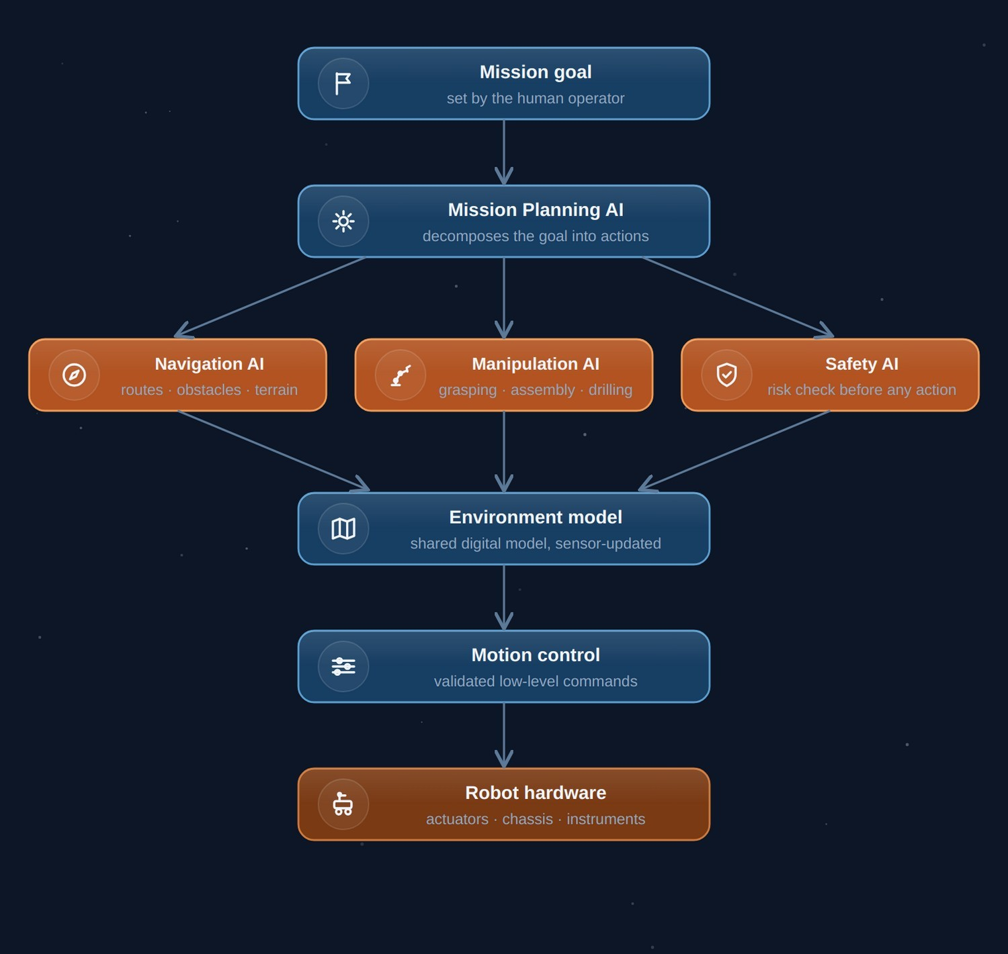 | Fig. 5.1. The modular architecture of the avatar’s artificial intelligence

5.4 Mission Planning AI
The first layer of the AI. Its task is to transform the human’s goal into a sequence of actions. For example, the operator sends the command: “Explore the southern part of the crater.” Mission Planning AI breaks the task down:
- Build a map of the area.
- Select a safe route.
- Identify interesting geological features.
- Plan the sampling.
- Hand off the assignments to the specialized subsystems.

5.5 Navigation AI
The navigation module is responsible for:
- route construction;
- obstacle avoidance;
- terrain analysis;
- rollover prevention;
- energy economy.
Navigation must account for the features of the Martian surface: sandy patches, large rocks, slopes, dust, and limited visibility. A similar approach in principle is already used in the AutoNav system of the Perseverance rover, which drove roughly 88% of the distance covered in its first Martian year without direct operator involvement [8][9].

5.6 Manipulation AI
This module controls the manipulators. For example:
- pick up a sample;
- open a container;
- replace a part;
- install a solar panel;
- connect a cable.
If a task cannot be performed safely, the system halts execution and requests new instructions.

5.7 Safety AI
Safety has the highest priority. Every task is checked before execution.
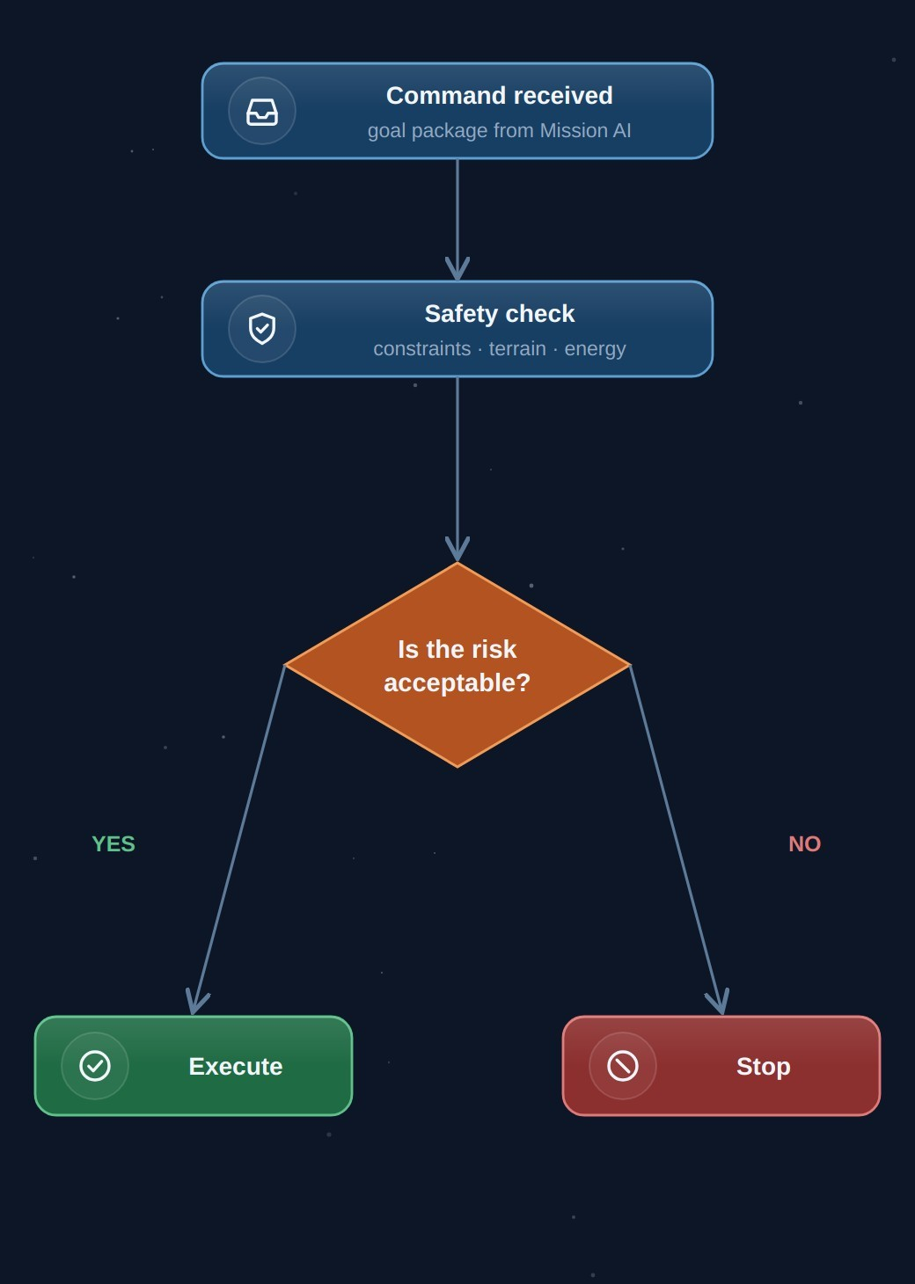 | Fig. 5.2. The decision logic of the Safety AI module
The AI must not perform actions that could damage equipment or threaten the entire mission.

5.8 Environment Model
Each robot maintains a digital model of its environment. It includes:
- a map of the terrain;
- the location of obstacles;
- the state of equipment;
- energy resources;
- weather conditions.
This model is continuously updated from sensor data.

5.9 Self-Learning
Within this concept, the robot is not expected to modify its base algorithms on its own during a mission. This is an important engineering constraint. During the execution of mission-critical tasks it is preferable to use pre-validated models. Software updates should occur only after testing and confirmation by specialists.

5.10 Operation During Loss of Communication
If the link with Earth is lost, the robot does not continue performing complex tasks uncontrolled. Possible scenarios:
- stop;
- enter safe mode;
- complete the current safe operation;
- save all data;
- wait for communication to be restored.
Such behavior reduces the likelihood of equipment damage.

5.11 One Operator — Multiple Robots
As autonomy develops, a single operator will be able to control several specialized platforms, interacting not with each mechanism individually but with a shared control system: Operator → Mission AI → Scientific Rover / Construction Robot / Drone / Cargo Robot.

5.12 Limitations of Artificial Intelligence
Despite rapid progress, AI has limitations that this concept treats as permanent design conditions rather than as problems awaiting a solution:
- errors in perceiving the environment;
- inability to act correctly in situations outside the modelled fault space (Section 5.13);
- unreliable self-assessment of confidence on out-of-distribution inputs;
- dependence on sensor quality;
- limited ability to explain decisions;
- severe onboard memory and compute budgets relative to terrestrial systems;
- the need for careful validation of algorithms before use.
For this reason, within the project the AI is regarded as a tool to support mission execution, not as a fully independent researcher.

5.13 Unforeseen Failures and the Compute Constraint
The single most serious objection to any goal-based architecture concerns the boundary of the modelled fault space. An onboard planner-executive — from Remote Agent [26] to today’s rover flight software — detects, isolates, and recovers from faults that were enumerated during design. Its competence ends precisely where enumeration ended. A situation absent from the fault model is not handled badly; it is not handled at all, and the system’s correct behaviour is to stop.
It must be stated plainly that contemporary artificial intelligence does not remove this boundary. Learned perception widens the set of recognisable situations; it does not widen the set of situations in which correct action is known. Worse, the confidence estimates of learned components degrade exactly where they would be most valuable — on inputs outside the training distribution — so the system is least able to know that it does not know at the moment this matters most.
The hardware constraint compounds this. Flight computing has lagged terrestrial computing by roughly two decades: the RAD750-class processors flown on Curiosity and Perseverance operate in the hundreds of MIPS, and enabling AutoNav’s stereo processing required adding a dedicated vision co-processor rather than software alone [8][9]. The constraint is now easing — NASA/JPL’s High Performance Spaceflight Computing processor, developed with Microchip Technology, entered environmental and performance testing at JPL in February 2026 and is reported to benchmark at roughly 500× current radiation-hardened flight processors [31][32]. But it is not yet flight-qualified and no mission has been named, so no architecture may currently assume it. A concept that becomes feasible only on the arrival of a processor still in qualification is a concept with a single point of failure outside its own control.
The position of this document. The Mars Avatar Project does not claim that fleet autonomy solves the unmodelled-failure problem. It claims something weaker and, we believe, defensible: that a fleet lowers the cost of not having solved it.
For a single vehicle, an unmodelled anomaly is potentially terminal. The platform is the mission; no diagnostic instrument other than its own — possibly failing — sensors is available; and the next intervention is one communication cycle away. For a fleet under a shared coordination layer, the same anomaly is a scheduling event:
- Safe-stop remains the default. Nothing above is a licence for the affected platform to improvise; the behaviour prescribed in Section 5.10 is unchanged.
- The subtask returns to auction. Work in progress is reallocated to a platform with the required capability (Section 6.5), so mission throughput degrades rather than halting.
- Diagnosis becomes possible. A second platform can approach and observe the affected one externally — an option a single rover structurally lacks — and the maintenance platform receives a diagnostic task. Where a single vehicle can only report telemetry, a fleet can look at itself.
The limits of this argument. Redundancy answers independent failures and does not answer correlated ones. A regional dust storm, a software defect common to every platform, or a systematic error in the shared world model will strike the fleet as a unit, and adding platforms provides no protection whatever. Common-mode failure is therefore a distinct design concern, requiring diversity in implementation and staggered software rollout rather than duplication of hardware. Nor does redundancy address the case in which an anomaly is misdiagnosed and reallocation propagates the underlying fault to a second platform.
The honest summary is that fleet architecture converts a class of mission-loss risks into a class of throughput losses, at the price of coordination overhead — and leaves correlated failures untouched. That is a real gain, and a smaller one than an unqualified appeal to “autonomy” would suggest.

5.14 Chapter Conclusions
Artificial intelligence is a key element of the Mars Avatar Project architecture, because it makes it possible to compensate for the physically unavoidable communication delay between Earth and Mars. In the proposed concept, the AI does not replace the human but provides autonomous execution of local actions within the goals set and the constraints defined in advance. This approach combines the advantages of human decision-making with the capabilities of modern autonomous robotic systems and is consistent with the current direction of development in space robotics.

Chapter 6. Mission AI Architecture
The single most underdeveloped layer in today’s planetary robotics is not the robot and not the operator — it is the intelligence that coordinates a fleet.

6.1 The Place of Mission AI in the System
The preceding chapters define Mission AI as an “intelligent dispatcher” between the operator and the fleet but do not describe its internal design. Yet this layer is the least-developed area in current programs (see Section 3.8) and therefore the project’s principal original contribution. This chapter specifies a reference architecture for Mission AI: five layers, the goal-package protocol, decision categories, and quality metrics.

6.2 Five-Layer Reference Architecture
Layer 1. Goal Interpreter. Transforms the operator’s goal (“explore the southern part of the crater”) into a formal task: a measurable result, constraints, success criteria, and an allowable level of autonomy. If the goal is ambiguous, the interpreter does not “guess” but returns clarifying options to the operator — this is cheaper than erroneous execution under a latency of tens of minutes.
Layer 2. Fleet Planner. Decomposes the task into subtasks and distributes them among platforms according to their specialization, position, charge, and current load. The base mechanism is market-based (auction) task-allocation algorithms: each platform “bids” a price reflecting its cost, and decentralized consensus protocols such as CBBA guarantee conflict-free allocation even under incomplete fleet connectivity [29]. The choice of a decentralized mechanism is fundamental: the fleet must remain operational if any node fails, including the central planner itself.
Layer 3. Shared World Model. A single digital model of the environment to which all platforms write: a geometric layer (maps, obstacles), a semantic layer (rock types, infrastructure objects), and a dynamic layer (weather, energy, equipment state). A copy of the model is synchronized to Earth and serves as the basis for the operator’s virtual environment (Section 9.5) — the operator always works with the latest agreed “snapshot” of Mars.
Layer 4. Execution Monitor. Compares actual progress against the plan, detects deviations (a task running longer than planned, a sensor giving contradictory data, a platform becoming unavailable), and initiates replanning within its authority. It inherits the approach of NASA’s onboard planner-executives: Remote Agent on Deep Space 1 (1999) — the first AI to autonomously operate a spacecraft [26]; the CASPER/ASE pairing on the EO-1 satellite autonomously replanned science observations for over a decade [27].
Layer 5. Safety & Approval Gate. The final filter before any action is executed: it classifies actions into categories (see Section 6.4), blocks prohibited ones, queues risky ones for Earth approval, and maintains an immutable log of decisions with a “why” explanation — the basis for later review and for the explainability requirement of Section 12.7.

6.3 The Goal Package Protocol
The packet principle for commands, described in detail later in Section 7.7, is formalized here. The goal package is the minimal unit of exchange between Earth and Mission AI:
- goal_id, priority, deadline — identification and place in the queue;
- objective — a measurable result (“a sample of mass ≥ 50 g delivered from sector B12”);
- constraints — prohibitions and limits (zones, slopes, energy consumption, wear);
- success_criteria — formal completion conditions, automatically verifiable;
- autonomy_level — which classes of decisions may be made without Earth (see Section 6.4);
- fallback — prescribed behavior when execution is impossible (return, wait, proceed to the next goal).
The response package is symmetric: result, log of key decisions with justifications, deviations from the plan, and updates to the world model. The protocol’s formality is a condition of verifiability: both the Stage I simulation trials and the certification before Stage III reduce to checking the system’s behavior over a set of goal packages.

6.4 Decision Categories and Approval Levels
Class | Example Actions | Who Approves | Typical Latency
A — critical | First drilling in a new rock type; movement on a slope above threshold; any action near another platform; irreversible consumption of a resource | Operator on Earth | Hours (comms cycle)
B — standard | Route in a surveyed zone; sampling by a validated procedure; nominal charging | Mission AI, with report to Earth | Seconds–minutes
C — internal | Stabilization, thermal regulation, local obstacle avoidance, self-diagnosis | The platform’s onboard AI | Milliseconds
Class boundaries are not a constant but a parameter of the goal package: as trust statistics accumulate, the operator may move routine actions from Class A to Class B. This provides a controllable trajectory of increasing autonomy — instead of a binary choice between “the human controls everything” and “the AI decides everything.”

6.5 Behavior Under Degradation
The architecture defines a degradation hierarchy:
- An unmodelled anomaly on a platform — the platform enters safe mode and does not attempt recovery outside its validated procedures. Its active subtasks return to auction; the maintenance platform receives a diagnostic task; and where the anomaly may be systematic, the Execution Monitor suspends the same procedure across the fleet pending Earth review. This last provision is the fleet’s only defence against a common-mode fault and must not be optional (Section 5.13).
- Loss of the link with Earth — the fleet completes Class B/C tasks within active packages, and no new Class A tasks are begun (consistent with Section 5.10).
- Loss of the central Mission AI node — platforms continue their current subtasks under the decentralized protocol and gather at a pre-designated rally point.
- Loss of an individual platform — its subtasks return to auction and are reallocated; the maintenance robot receives a diagnostic task.
Each degradation level must be a separate Stage I test scenario.

6.6 Mission AI Quality Metrics
- Goal Completion Rate — the share of goal packages completed against success criteria without reformulating the goal;
- Intervention Rate — the average number of operator interventions per package (the principal metric of autonomy maturity; the target trend is a monotonic decline from stage to stage);
- Safe-Stop Rate — the frequency of transitions to safe mode (high indicates immature perception, zero is suspiciously aggressive tuning);
- Coordination Overhead — the share of fleet time spent on coordination rather than work;
- Unmodelled Anomaly Rate — the frequency of events for which no contingency existed, per platform-hour. Unlike the metrics above, the target is not a monotonic decline but an honest measurement: a reported rate of zero indicates an incomplete anomaly taxonomy, not a mature system;
- Anomaly Recovery Cost — fleet-hours lost between an unmodelled anomaly and the resumption of the affected subtask. This is the quantity the fleet architecture claims to reduce, and therefore the quantity on which the claim of Section 5.13 stands or falls.
These metrics translate the success criteria of Section 10.9 from qualitative statements into measurable quantities and make it possible to compare versions of the system objectively across stages.

6.7 Open Research Problems
- Verification of learned components: formal methods (Section 12.4) apply to classical logic but not to neural-network perception; hybrid schemes of “learned perception + verifiable decision-making” are needed.
- Sim-to-real transfer: Martian conditions cannot be fully reproduced on Earth; a methodology for quantifying the gap is required.
- Coordination under local-network fragmentation: the behavior of auction protocols when the fleet is split into isolated groups for extended periods.
- Detection of the unmodelled case: distinguishing “a situation the system handles poorly” from “a situation outside the system’s competence” is unsolved, and is a harder problem than the recovery that follows it. Without a reliable detector, both the safe-stop default and the reallocation logic of Section 6.5 are triggered by the wrong signal.
- Common-mode failure in homogeneous fleets: the degree of implementation diversity required to make redundancy meaningful, weighed against the cost of maintaining several independent software stacks.
Each of these problems is a research program in its own right, and it is these — not the appearance of the robots — that define the project’s true critical path.

Chapter 7. Interplanetary Communication and Mission Control
In interplanetary exploration, communication is not simply a channel for transmitting information — it is a fundamental architectural constraint.

7.1 The Role of the Communication System
In traditional robotics, communication provides data exchange between operator and machine. In the interplanetary environment its role is much broader. The communication system must provide:
- transmission of mission goals;
- receipt of scientific data;
- monitoring of equipment status;
- coordination of multiple robots;
- safe operation under long delays.
The communication architecture becomes one of the key elements of the entire mission.

7.2 Physical Constraints
The distance between Earth and Mars changes constantly. As a result, the one-way signal travel time is approximately:
Distance | Delay (one way)
Minimum | ~4 minutes (physical minimum ~3 minutes at closest approach)
Average | ~12 minutes
Maximum | ~22 minutes
These values are determined by the speed of light and cannot be eliminated by improving equipment [4][5]. Consequently, the Mars Avatar Project architecture is built with this fundamental property in mind.

7.3 Communication Architecture
Each layer performs its own function and does not duplicate the others.
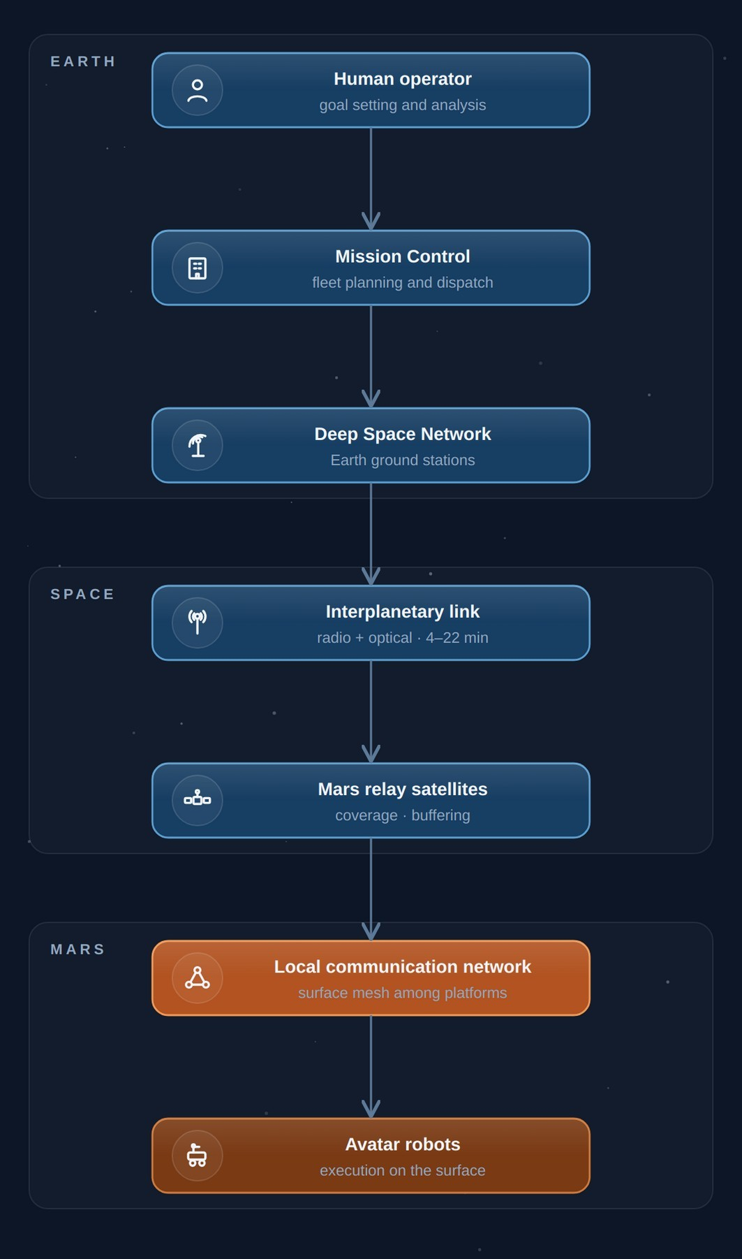 | Fig. 7.1. The layers of the Mars Avatar Project communication system

7.4 Mission Control Center
The control center is the intelligent coordination node. Its tasks:
- distributing tasks among robots;
- analyzing incoming data;
- planning operations;
- monitoring resources;
- interacting with the science team;
- preparing new commands.
Mission Control works with goals, not with the individual movements of each robot.

7.5 Mars Relay Network
Orbital relays make it possible to:
- increase surface coverage;
- reduce the likelihood of losing communication;
- organize data exchange among robots;
- provide storage of part of the information until the link is restored.
As the infrastructure develops, the number of relays can grow [6][7].

7.6 The Local Mars Network
After the orbiters receive data, communication takes place within a local network. It may unite rovers, construction robots, drones, laboratories, power stations, and future crewed bases. Thus, a distributed robotic infrastructure takes shape.

7.7 Command Transmission
Instead of continuous control, a packet principle is used. A command contains a goal, constraints, a priority, an allowable execution time, and criteria for successful completion. For example: Mission Goal: Collect Rock Sample · Location: Sector B12 · Priority: High · Safety: Maximum · Return Data. Having received such a package, the local AI plans the execution on its own.

7.8 Transmission of Scientific Data
Returned to Earth are: images, terrain maps, spectral measurements, telemetry, AI reports, and event logs. Transmission can occur with varying degrees of priority. High priority: emergency messages; the state of equipment; critical scientific discoveries. Low priority: archival images; operation logs; diagnostic information.

7.9 Operation During Loss of Communication
Communication may be temporarily unavailable for various reasons: solar interference, technical malfunctions, constraints of orbital geometry. In such cases the system must:
- save current data;
- enter safe mode;
- complete only safe operations;
- wait for communication to be restored.
This reduces the likelihood of losing equipment.

7.10 Network Scaling
In the early stages the system may consist of a few robots. Later, the architecture allows expansion to a distributed network. All platforms operate as a single coordinated system.
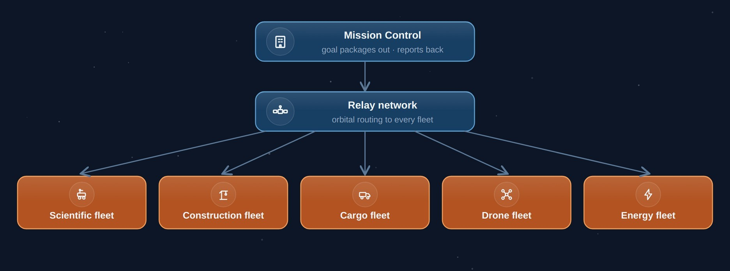 | Fig. 7.2. Scaling of the distributed avatar network

7.11 Cybersecurity
The interplanetary network must provide:
- authentication of commands;
- protection against data spoofing;
- verification of packet integrity;
- redundancy of communication channels;
- logging of critical actions.
Security is treated as an integral part of the architecture, not as an add-on feature.

7.12 Chapter Conclusions
The communication system in the Mars Avatar Project is not merely a means of transmitting information but the foundation of the entire control architecture. Because of the fundamental limits of the speed of light, control is built on the principle “goal → autonomous execution → feedback.” This approach makes effective use of the combination of human decision-making and the autonomous operation of robotic systems.

Chapter 8. Robotic Avatars
The robot is not intended to replace the explorer. It is intended to become the explorer’s physical presence where the human body cannot safely operate.

8.1 General Concept
At the heart of the Mars Avatar Project lies the idea of specialized robotic platforms — avatars — each designed to perform a particular class of tasks. Instead of building a single universal robot, the project envisions a modular ecosystem in which different types of platforms work together and complement one another. This approach is widely used in modern engineering, since specialized systems are often more effective than universal ones.

8.2 Core Requirements
Each robotic avatar must have the following characteristics:
- high autonomy;
- radiation tolerance;
- a modular design;
- the ability to receive remote software updates;
- a self-diagnostic system;
- a safe operating mode upon loss of communication;
- compatibility with the project’s shared infrastructure.

8.3 Classes of Robotic Platforms

Scientific Rover
The primary research platform. Functions: geological research, drilling, sample collection, spectral analysis, cartography, ice prospecting. Equipment: a manipulator, high-resolution cameras, lidar, spectrometers, a drilling module, navigation sensors.

Construction Avatar
Purpose: infrastructure construction. Capabilities: installing solar panels, erecting structures, assembling modules, cable laying, site preparation. This is one of the key elements in creating a future base.

Cargo Robot
Designed for logistics. Main functions: hauling equipment, delivering spare parts, transporting samples, moving construction materials.

Drone
Aerial vehicles can perform reconnaissance, map building, route finding, equipment inspection, and monitoring the condition of assets. Given the thin Martian atmosphere, their design must account for the specifics of flight in these conditions.

Laboratory Unit
The autonomous laboratory performs chemical analysis, biological analysis, sample preparation, long-term storage of materials, and transmission of research results.

Maintenance Robot
Purpose: repairing other robots. Functions: diagnostics, module replacement, equipment cleaning, routine maintenance. This extends the service life of the entire system.

8.4 Modular Design
Each avatar consists of interchangeable modules: power, mobility, manipulator, sensor, communication, and the AI computer. This approach simplifies repair and upgrades.
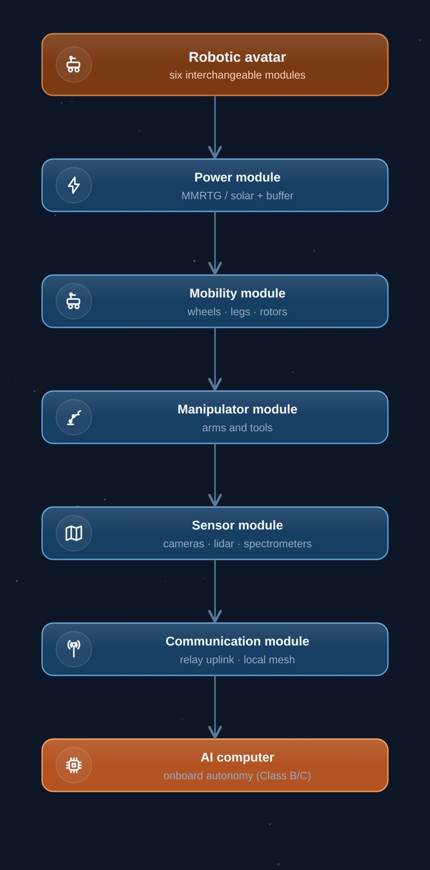 | Fig. 8.1. The modular structure of a robotic avatar

8.5 The Power System

Solar Panels
Advantages: high reliability; no consumable fuel; ease of operation. Disadvantages: dependence on illumination; the impact of dust storms.

Radioisotope Power Sources
Advantages: stable operation; independence from the time of day. Disadvantages: limited availability; complexity of development and use. The specific choice depends on the mission type and power requirements. Practical confirmation of this choice comes from NASA’s experience: the Opportunity rover, which ran on solar panels, was lost in 2018 to a global dust storm, whereas Curiosity and Perseverance, equipped with the MMRTG radioisotope source, continue operating regardless of illumination and dust [10][11][12].

8.6 The Sensor System
Each avatar must perceive its environment. A possible sensor suite:
- stereo cameras;
- lidar;
- radar;
- spectrometers;
- temperature sensors;
- inertial navigation;
- manipulator force sensors.
The combined operation of these sensors makes it possible to build a digital model of the environment.

8.7 Self-Diagnosis
Each robot continuously assesses battery charge, component temperatures, motor condition, link quality, and computing-system errors. Upon detecting a fault, the system can limit functionality, enter safe mode, notify the operator, or request servicing.

8.8 Robot Interaction
The collective work of specialized platforms is considered the most effective. For example: a drone maps the area; the scientific rover takes samples; the cargo robot delivers the container; the laboratory unit performs analysis; Mission Control receives the results. Each performs its own function.
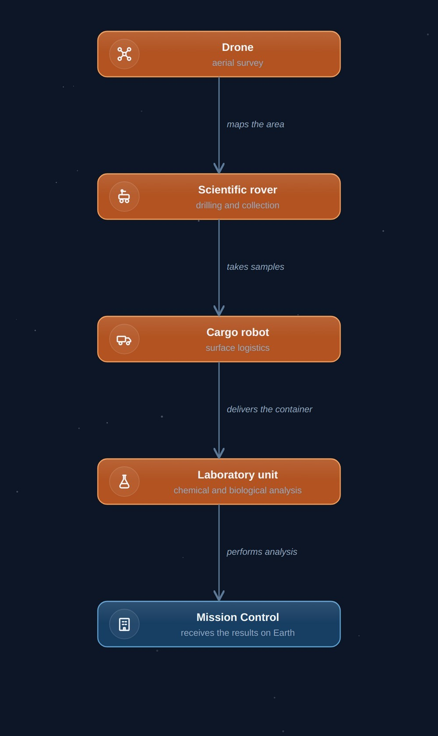 | Fig. 8.2. An example of specialized platforms working together

8.9 Scaling
The architecture allows gradual development. The tiers below describe fleet scale and are independent of the programme stages I–V of Chapter 10.
Capability tier | Structure
Tier 1 | 1 operator → 1 robot
Tier 2 | Mission Control → 5–10 specialized robots (the Stage III fleet of Chapter 11)
Tier 3 | Mission Control → 100 autonomous platforms
Tier 4 | Planetary robotic infrastructure → thousands of interacting systems
This approach allows capabilities to grow without changing the base architecture.

8.10 Limitations
Robotic systems also have limitations:
- mechanical wear;
- dust damage;
- extreme temperatures;
- energy constraints;
- the need for periodic servicing.
Consequently, the project does not treat robots as failure-proof systems. Reliability is achieved through redundancy, modularity, and serviceability.

8.11 Chapter Conclusions
Robotic avatars are the physical layer of the Mars Avatar Project architecture. Instead of building one universal machine, the concept envisions specialized platforms united by a shared control system and autonomous AI. Modularity, distribution of functions, and the ability to scale gradually allow the architecture to be adapted to a variety of tasks — from scientific research to preparing infrastructure for future crewed expeditions.

Chapter 9. The Human–Machine Interface: From Traditional Control to Telepresence
The quality of exploration depends not only on the intelligence of the robot, but also on how naturally a human can interact with it.

9.1 Introduction
One of the central tasks of the Mars Avatar Project is creating effective interaction between the human and the robotic system. Unlike traditional remote control, where the operator commands each movement of the robot, the proposed concept involves transmitting goals and intentions rather than individual motor commands. This requires developing interfaces that allow a person to quickly understand what is happening and to interact effectively with the system even under a large communication delay.

9.2 The Evolution of Control Interfaces
Development is proposed to proceed in stages.
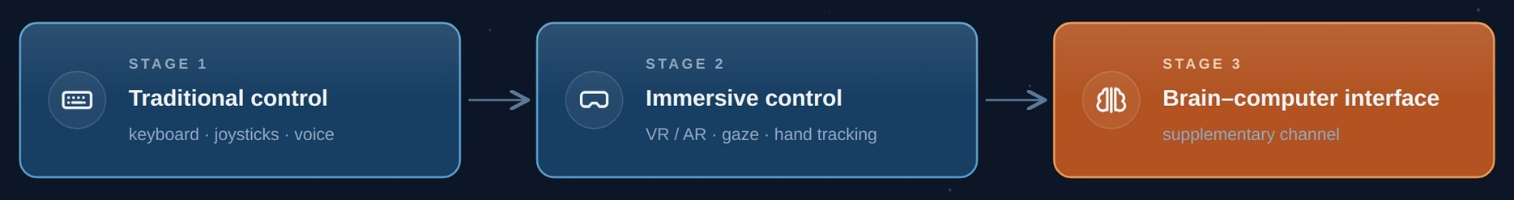 | Fig. 9.1. The evolution of human–avatar interaction interfaces

Stage 1 — Present-Day Technologies
In use: keyboard and mouse, game controllers, professional joysticks, touch panels, voice control. These technologies are already widely used in robotics and industry.

Stage 2 — Immersive Control
Additionally used: VR headsets, AR interfaces, spatial controllers, hand tracking, eye tracking. The operator gains a more natural picture of the working environment.

Stage 3 — Additional Input Channels
In the longer term, further input channels — including neural interfaces — may supplement the above. The concept does not assume that any of them replaces conventional control, and none is required for the architecture to function (Section 9.3).

9.3 A Note on Neural Interfaces
Brain–computer interfaces appear in this concept only as a possible late addition to the interface layer, and nothing in the architecture depends on them. The operator’s task — formulating goals, evaluating reports, approving Class A decisions — is bounded by the communication cycle, not by input bandwidth: when a decision takes minutes to reach Mars, the speed at which it is entered is not the binding constraint. Neural interfaces are therefore excluded from the critical path of Chapter 6 and from the transition criteria of Chapter 10. A short survey of their present state is given in Appendix B.

9.4 Telepresence
Telepresence does not mean creating the illusion of being on Mars in real time; it means giving the operator the fullest possible picture of what is happening, given the unavoidable communication delay.
The operator receives images, three-dimensional maps, telemetry, analysis results, and AI reports. This allows informed decisions to be made even when data arrives with a delay.

9.5 The Role of Virtual Reality
VR can be used for planning operations, training operators, simulating missions, analyzing the environment, and visualizing routes. The virtual environment is built from data received from Mars.

9.6 Haptic Feedback
In the future, devices that convey the sensation of touch or resistance may be employed. Such technologies could improve task precision, but their use under interplanetary latency requires further research.

9.7 The Operator’s Work
In the proposed architecture, the operator:
- formulates the goal;
- analyzes incoming data;
- evaluates the AI’s proposals;
- approves mission-critical actions;
- adjusts the mission as needed.
Thus, the operator remains the director of the process, not the direct executor of every movement.

9.8 Limitations
Even as interfaces develop, objective limitations remain: communication delay, limited channel bandwidth, possible signal-recognition errors, the operator’s cognitive load, and the need for training on the system. These limitations must be taken into account when designing the interface.

9.9 Development Roadmap
Stage | Capabilities
Today | Joysticks, keyboard, voice control, VR
5–10 years | Tighter VR integration, eye tracking, improved interfaces
10–20 years | Improved shared-autonomy interfaces; additional input channels as optional supplements
Long term | More natural forms of human–robot interaction (contingent on further scientific breakthroughs)

9.10 Chapter Conclusions
The human–machine interface is the connecting link between the operator and the robotic infrastructure of the Mars Avatar Project. The concept envisions gradual evolution: from present-day control tools to more natural forms of interaction, including prospective neural interfaces. At the same time, the fundamental limitation associated with the signal delay between Earth and Mars remains. Even the most advanced interfaces therefore do not remove the need for autonomous operation of the local AI; rather, they serve as tools for more effective goal setting, data analysis, and human decision-making.

Chapter 10. Technology Roadmap
A vision becomes an engineering project only when it is divided into achievable steps.

10.1 The Principle of Staged Development
The Mars Avatar Project does not envision building the complete system in a single step. The concept is based on the gradual development of technologies, where each subsequent level builds on the results of the previous one. This approach makes it possible to:
- test hypotheses experimentally;
- reduce technical risks;
- use technologies that already exist;
- adapt the architecture as new solutions appear.
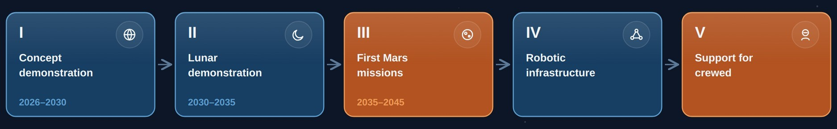 | Fig. 10.1. The implementation stages of the Mars Avatar Project

10.2 Stage I — Concept Demonstration (2026–2030)
Goal: validate the core principles of the Mars Avatar Project under terrestrial conditions. Main tasks: developing the software architecture; building the control center; integrating the VR interface; using existing robots; simulating a communication delay of 20–30 minutes; testing the autonomous AI. Demonstration scenario: the operator is in a laboratory; the robot works at a remote test range; all commands pass through an artificial delay. The AI, on its own, plans a route, avoids obstacles, performs the assigned task, and returns a report. Result: creation of the first experimental prototype of the architecture.

10.3 Stage II — Lunar Demonstration (2030–2035)
After successful terrestrial trials, the system can be adapted for use on the Moon. Why the Moon?
- a much shorter distance;
- the possibility of more frequent missions;
- the existence of international exploration programs;
- relatively simple logistics.
At this stage it is possible to test autonomous navigation, control of multiple robots, infrastructure construction, and long-duration system operation.

10.4 Stage III — First Robotic Missions on Mars (2035–2045)
At this stage the architecture is applied directly on Mars. Possible tasks:
- building landing pads;
- preparing the power infrastructure;
- creating storage depots;
- geological research;
- scouting sites for future bases.
The operator now manages not a single robot but the entire mission.

10.5 Stage IV — Robotic Infrastructure
As experience accumulates, individual platforms are united into a single network. Possible elements: power stations, automated warehouses, repair stations, transport hubs, science laboratories, autonomous construction complexes. In effect, the planet’s first robotic infrastructure emerges.

10.6 Stage V — Support for Crewed Missions
Once the infrastructure exists, safer crewed expeditions become possible. By that time, robots can prepare a landing pad, deploy solar power stations, check the equipment, build up resource reserves, and prepare habitation modules. Thus, the first crews arrive in a partially prepared environment.

10.7 The Long-Term Outlook
In the longer term, the architecture can be adapted for other objects in the Solar System: the Moon, Phobos, Deimos, Europa, Titan, asteroids. It is important to emphasize that this is a direction for further research, not a ready mission plan.

10.8 Technology Readiness
Component | Maturity Level
Robotic platforms | High
Interplanetary communication | High
Autonomous navigation | Medium–high
Local AI | Medium
Multi-robot systems | Medium
Onboard computing for autonomy | Medium (see 5.13)
Non-invasive BCIs | Medium
High-performance BCIs | Low–medium
Full telepresence | Long-term goal
This table is not an official TRL assessment; it presents a qualitative classification of technology maturity within the concept.

10.9 Success Criteria
Each stage must conclude with an objective verification of results. Example criteria:
- Stage I: the robot performs a task under an artificial communication delay; the AI operates safely without operator involvement.
- Stage II: several robots coordinate joint work; the architecture’s reliability is confirmed.
Stage I additionally requires a failure-injection campaign. Anomalies must be introduced by a team independent of the developers and drawn from outside the documented fault model — otherwise the trial measures only that the system handles what it was built to handle. Reported results must include the Unmodelled Anomaly Rate and the Anomaly Recovery Cost (Section 6.6), and the criterion for passing Stage I is not the absence of unhandled anomalies but the demonstrated reallocation of their subtasks without propagation of the fault.

10.10 Principal Risks
At every stage the following must be considered: technical limitations, AI reliability, power supply, communication delay, development cost, and the effects of the Martian environment. The transition between stages is therefore possible only after the successful completion of the previous one.

10.11 Chapter Conclusions
The Mars Avatar Project is treated as a long-term research and development program, not a single mission. The proposed roadmap allows the key elements of the architecture to be verified in sequence — from a terrestrial prototype to a robotic infrastructure capable of supporting future crewed expeditions. Each stage is based on the principle of gradually reducing uncertainty: new technologies are introduced only after the experimental verification of previous solutions. This approach follows the practice of major engineering programs and makes the concept more realistic and suitable for discussion.

Chapter 11. Quantitative Estimates
An architecture without numbers is a story. An architecture with numbers is an engineering argument.

11.1 Method and Caveats
All estimates in this chapter are order-of-magnitude figures based on open data from completed and operational missions. Their purpose is not budgeting but a test of the concept’s central economic argument: that robotic infrastructure establishes a working surface presence several times more cheaply than a crewed expedition — by a factor of three to six against the lower bound of published crewed estimates (Section 11.4), not by the order of magnitude claimed in earlier versions of this document.
A caveat on comparability. The comparison drawn in this chapter is not like-for-like, and it would be dishonest to present it as such. A crewed expedition and a robotic fleet do not deliver the same product: the expedition returns people, samples, and real-time scientific judgement; the fleet returns data and built infrastructure, and nothing physical. What the figures below compare is the cost of establishing a working presence on the surface — not the cost of equivalent scientific output, which cannot presently be quantified for either side. Read in that narrower sense, the gap is large enough to matter; read as “the same mission for less money,” it is simply wrong.

11.2 Cost of Robotic Missions: Actual Data
Mission | Program Cost | Comment
Mars Pathfinder + Sojourner (1997) | ~$0.3B | First rover; demonstration of low-cost landing
Spirit + Opportunity (MER, 2004) | ~$0.8B (prime mission) | Two rovers; Opportunity operated for 14 years
Curiosity (MSL, 2012) | ~$2.5B | 900 kg, MMRTG, still operating
Perseverance + Ingenuity (2021) | ~$2.7B (full lifecycle) | 1,025 kg; Ingenuity helicopter ~$0.085B
Mars Sample Return (cancelled, 2026) | estimate grew from ~$3–4B to ~$11B (2024 independent review); reworked options near ~$7B did not save the program | Funding ended by the U.S. Congress in January 2026 [22]
Two conclusions follow from the table. First, the cost of a flagship robotic platform of the Perseverance class is ~$2–3 billion, of which a substantial share is one-time development cost: serial production of identical platforms lowers the unit cost. Second, the history of Mars Sample Return is an important cautionary tale: the growth of the estimate to ~$11B led to the program’s cancellation [22]. The return architecture (ascent from Mars, orbital rendezvous) proved to be the principal source of complexity. MAP does not have this complexity in principle: avatars do not return, and data is transmitted over communication links.

11.3 Cost of a Crewed Expedition: Range of Estimates
No official budget for a crewed Mars program exists. Reference points come from adjacent programs and independent analyses: the Apollo program, adjusted to current prices, is estimated at roughly $260–280 billion; the construction and operation of the ISS at about $150 billion; independent estimates of a full crewed Mars program based on architectures such as NASA DRA 5.0 [25] give a range from ~$100 to ~$500 billion, depending on the number of expeditions and the degree of hardware reuse. Even the lower bound of this range exceeds the cost of a flagship robotic mission by one to two orders of magnitude.

11.4 Model Calculation: A Fleet of Avatars vs. an Expedition
Consider the Stage III fleet from the roadmap: 10 specialized platforms (2 science rovers, 3 construction robots, 2 cargo robots, 1 laboratory, 1 maintenance robot, 1 drone set) plus 2 orbital relays.
Item | Estimate | Basis
Development of 6 platform types | $10–16B | ~$2–2.5B for the first unit of a science-rover-class platform (MSL / Mars 2020), less for the simpler cargo and drone platforms. The construction and maintenance platforms have no flown analogue; their share of this line carries the widest uncertainty in the model.
Serial units (4) | $2–4B | assumes a serial copy at ~40% of first-unit cost (MER analogy: two rovers in one programme)
Surface power segment | $2–4B | two Kilopower-class fission units (~10 kW) with qualification and deployment; no flight system of this class exists, and the figure extrapolates from the KRUSTY ground test [24]
Relays (2) | $1–1.5B | Mars Reconnaissance Orbiter class
Launches (6–8 heavy LVs) | $0.7–2B | commercial heavy launch vehicles
Ground segment and operations, 10 years | $2–4B | analogous to MSL / Mars 2020 operating budgets
TOTAL | ≈ $18–31B | against ≥ $100B for the lower bound of crewed estimates
The fleet therefore lands roughly three to six times below the lower bound of published crewed estimates. This is a narrower margin than earlier versions of this document claimed, for two reasons: the earlier model omitted the surface power segment entirely, and it priced platforms with no flown analogue as though they were science rovers. Two distortions remain, and they point in opposite directions. In favour of the robotic case: the crewed budget does not include the landing and ascent infrastructure that, by the logic of Stage V, robots must build in advance in any event. Against it: the crewed figure comes from architectures studied in detail for decades, whereas the fleet figure extrapolates from missions that performed no construction work at all.

11.5 Mass Constraint: EDL
Landing on Mars (Entry, Descent, Landing) is the most severe mass constraint. The proven maximum landed payload is ~1 tonne (Curiosity, Perseverance, the sky-crane scheme). Crewed architectures of the DRA 5.0 class require landing modules of tens of tonnes [25] — a technology that has never been demonstrated. MAP’s robotic platforms fit within the proven range of ≤1 t per vehicle, which allows the program to begin on existing landing technology. The advent of super-heavy systems (Starship class) would lift the constraint for robots as well — but MAP does not depend on it.

11.6 Energy Budget
An MMRTG source provides ~110 W of electrical power at the start of life [10] — sufficient for a science rover, but one to two orders of magnitude below the needs of a construction robot (several kilowatts when operating manipulators and moving cargo). Possible solutions: combining the MMRTG with buffer batteries for peak loads; deployable solar arrays with mechanized dust removal; low-power nuclear reactors of the Kilopower class — the KRUSTY ground prototype demonstrated a ~1 kWe unit of the Kilopower family (design range 1–10 kWe) in 2018 [24]. Energy is the bottleneck specifically of the construction scenario, not the science scenario, and should be a priority of Stages I–II.

11.7 Communication Bandwidth
The current relay via orbiters returns data on the order of hundreds of megabits to a few gigabits per sol per rover — adequate for telemetry and images, but limiting for the 3D models and video required by the interfaces of Chapter 9. The key change is laser communication: NASA’s DSOC experiment (2023–2025) demonstrated 267 Mbit/s at a distance of 31 million km and 8.3 Mbit/s at 2.7 AU — an increase of one to two orders of magnitude over radio links at comparable terminal mass [23]. For MAP this means that “dense” telepresence (streams of 3D maps and video, delayed but not bandwidth-starved) is technologically achievable within the horizon of Stages II–III.

11.8 Summary Comparison
Criterion | Crewed Expedition | Fleet of Avatars (Stage III)
Program cost | ≥ $100B | ≈ $18–31B
Landed mass per module | tens of tonnes (not demonstrated) | ≤ 1 t (proven)
Duration of surface operation | ~500 days (return window) | 10+ years (MER, MSL experience)
Risk to life | high | none
Return | mandatory (principal source of complexity) | not required
On-site reaction speed | seconds | minutes–hours (compensated by autonomy)
Scientific flexibility and intuition | maximal | limited by AI and sensor capabilities
Response to an unmodelled situation | human judgement, in seconds | safe-stop and reallocation, one comms cycle (5.13)
The honest conclusion from the table is symmetric: on cost the robotic architecture wins by a factor of three to six, and on risk to life and operating duration by a far wider margin; on reaction speed and on-site scientific intuition the human remains without peer.

11.9 What Would Invalidate These Estimates
An estimate is useful only if the conditions under which it fails are stated. This one fails if any of the following holds:
- Construction platforms do not scale from rover heritage. The model treats a construction avatar as a rover-class development carrying a different payload. If autonomous construction in 0.38 g with abrasive dust proves to be a distinct engineering discipline — which the absence of any flown precedent makes plausible — the development line could grow by a factor of two or more.
- Fission surface power costs more than the platforms it feeds. No flight-qualified Kilopower-class system exists. Should qualification approach the cost of a flagship mission, the power segment, not the fleet, becomes the dominant line.
- Serial production does not deliver the assumed discount. The 40% figure comes from a two-rover programme. It has never been tested across six platform types on a shared bus.
- Effective service life is shorter than assumed. The ten-year cycle rests on MER and MSL experience with vehicles that never performed physical work on other machines. A shorter life shifts the comparison materially, since the crewed case is bounded at ~500 days regardless.
The first two would not overturn the conclusion — a fleet at $50B still sits below the lower bound of the crewed range — but they would remove the “order of magnitude” framing used in earlier versions of this document, and that framing should not be relied upon.

Chapter 12. Analysis of Risks, Limitations, and Ethical Aspects
Every ambitious engineering concept must be evaluated not only by its potential, but also by its risks and limitations.

12.1 Introduction
Any architecture for an interplanetary robotic system faces numerous technical, organizational, and ethical challenges. The purpose of this section is not to prove the project’s absolute feasibility, but to identify the key limitations that must be taken into account as it develops further. It is precisely the understanding of limitations that turns a concept into an engineering research program.

12.2 Technical Risks

Equipment Reliability
The Martian environment differs greatly from Earth’s. The main factors: dust storms, extreme temperatures, radiation, mechanical wear, limited repair options. Equipment must therefore be designed for high fault tolerance and autonomous diagnostics.

Power Supply
Any autonomous system depends on energy. The main risks: declining solar-panel efficiency, dust accumulation, battery degradation, failure of power modules. The power system must therefore provide redundancy and different power sources depending on the mission’s tasks.

Artificial-Intelligence Failure
The AI may misinterpret a situation, err in classifying objects, choose a suboptimal route, or encounter a situation absent from its training data and from its fault model. The last of these is qualitatively different from the others and is treated separately in Section 5.13: it is not a defect to be engineered out but a permanent boundary of any pre-validated system. The architectural response is threefold — mission-critical decisions remain under human control; autonomous action is confined to predefined bounds; and the consequence of encountering the boundary is reduced, through fleet redundancy, from loss of the mission to loss of throughput. No element of this response makes the boundary itself go away.

12.3 Communication Risks
Communication between Earth and Mars can be disrupted for various reasons: solar activity, hardware malfunctions, damage to relays, data-transmission errors. The architecture must provide:
- command buffering;
- local data storage;
- a safe mode;
- automatic resumption of operation once the link is restored.

12.4 Software Risks
Modern autonomous systems comprise millions of lines of code. Possible problems: programming errors, faulty updates, component incompatibility, accumulation of computational errors. To reduce risk, the following are recommended:
- a modular architecture;
- independent testing;
- redundancy of critical components;
- formal verification of individual algorithms where possible.

12.5 Cybersecurity
Although interplanetary systems are less accessible to external interference, security remains an important task. It is necessary to ensure cryptographic protection of commands, operator authentication, protection of telemetry, logging of actions, and software version control. Security must be treated as part of the architecture from the very start of development.

12.6 Limitations of the Concept
The limitations of the project itself should be noted. The Mars Avatar Project does not claim that:
- today’s AI can fully replace the human;
- existing BCIs provide full telepresence;
- all the necessary technologies are already available.
On the contrary, the document proposes a research roadmap that shows which components already exist and which require further development.

12.7 Ethical Questions
The development of autonomous robotic systems raises a number of questions. For example:
- What degree of autonomy is acceptable?
- Which decisions must always be approved by a human?
- Who bears responsibility for the system’s errors?
- How can the transparency of AI decision-making be ensured?
Within the Mars Avatar Project, the following principle is proposed: the human retains responsibility for strategic decisions, while autonomous systems act only within predefined rules and goals.

12.8 Economic Risks
Building such an architecture will require prolonged research, international cooperation, significant financial resources, and the development of space infrastructure. The project should therefore be viewed as a long-term research program rather than a short-term commercial initiative.

12.9 Scientific Limitations
Many elements of the project have not yet been experimentally confirmed. For example: scalable multi-robot systems for interplanetary conditions; long-duration autonomous operation without human involvement; widespread use of high-performance BCIs in space missions. The following are therefore needed:
- experimental prototypes;
- trials on Earth;
- lunar demonstration missions;
- gradual verification of the architecture.

12.10 The Principle of Engineering Honesty
One of the key principles of the Mars Avatar Project is an open classification of technologies by readiness level:
- Established (green) — existing, proven solutions.
- Projected (amber) — expected directions of development.
- Long-Term Research (red) — ideas requiring fundamental scientific breakthroughs.
This approach helps avoid inflated expectations and makes the concept more transparent to the scientific community.

12.11 Chapter Conclusions
Any concept for exploring Mars must account not only for potential benefits but also for limitations. The Mars Avatar Project treats risks as an integral part of the engineering process. Instead of trying to ignore the difficulties, the project proposes staged hypothesis testing, gradual technology development, and continuous safety assessment. This approach follows the practice of developing complex technical systems, where reliability is achieved through the sequential verification of solutions, not by assuming their infallibility.

Chapter 13. Conclusion and Prospects
The greatest advances in exploration begin not with certainty, but with a well-founded question.

13.1 The Principal Conclusion: Investing in Presence, Not in a Destination
The traditional logic of space programs is built around a destination: “a program to fly to the Moon,” “a program to fly to Mars.” Each such program is an expense: its result is exhausted once the goal is reached. The Mars Avatar Project proposes the opposite logic. The object of investment is not a flight but a technology of presence: the ability of human intelligence to act at any point in the Solar System through autonomous robotic intermediaries. Such a technology has the properties of an asset:
- it accumulates: every executed goal package, every hour of autonomous operation, every adjusted decision-class boundary (Section 6.4) raises the maturity of the system for all future applications;
- it transfers: the architecture contains nothing specifically “Martian” — Mars merely sets the numerical values of parameters (delay of 4–22 min, gravity of 0.38 g, atmospheric composition);
- it scales: from one operator and one robot to a planetary robotic infrastructure without changing the base architecture (capability tiers, Section 8.9).
A crewed expedition possesses none of these properties. This does not make it unnecessary — it makes it the second step, not the first.

13.2 Why “Humans First” Is Poor Engineering, Not a Bold Dream
The limitations of crewed missions — radiation, duration, life support, cost of ≥ $100B, mandatory return — are examined in detail in Chapters 2 and 11. What matters here is the conclusion that follows from them. Sending a human into an unprepared environment is not an act of courage; it is a transfer onto the crew of risks that infrastructure was obliged to remove. No mature engineering practice works this way: reconnaissance, site preparation, and the deployment of power and communications precede the human. This is exactly the work performed by the robotic layer. The correct formulation is therefore not “humans are a dead end,” but: the human is too expensive and too vulnerable an instrument for first contact with an environment. The human remains irreplaceable where real-time scientific intuition and reaction to the wholly unforeseen are required — Table 11.8 honestly records this advantage. But paying for intuition with life support, radiation risk, and a return architecture makes sense only once the environment has been prepared and the routine work has already been taken over by robots.

13.3 Mars as a Proving Ground, Not as a Goal
In the logic of “presence technology,” the choice of Mars is explained not by romance but by methodology:
- The 4–22-minute delay is an honest stress test. A system designed for Martian latency automatically covers the Moon (seconds) and scales to the asteroid belt and the outer planets (tens of minutes to hours).
- Maximal scientific return per unit of risk. Water, geology, the question of life — Mars justifies the cost of the first deployment.
- Existing infrastructure. The relay network, proven ≤1 t landing schemes, and operational autonomous systems (AutoNav, AEGIS) mean the starting base already exists [6][8][28].
But the result of the program is measured not only in Martian data. The result is a verified, certified architecture of presence, applicable to the next object with a change of parameters — not of principles.

13.4 Key Conclusions of the Study
- Autonomy is not an option but a physical necessity. The speed of light makes direct teleoperation impossible over interplanetary distances; local AI is mandatory (Chapter 5).
- The human remains in command. The Human-in-Command principle is preserved at every level: goals, constraints, and critical decisions belong to the human; execution belongs to the system (Sections 4.3, 6.4).
- The least developed layer is fleet coordination. Not the robots and not the interfaces, but Mission AI — the intelligence coordinating a heterogeneous fleet — is the principal space of the project’s original contribution (Chapter 6).
- The architecture must develop in stages. Terrestrial prototype → lunar demonstration → Martian missions → infrastructure → support for expeditions; transitions between stages occur only against measurable criteria (Chapters 10, 6.6).
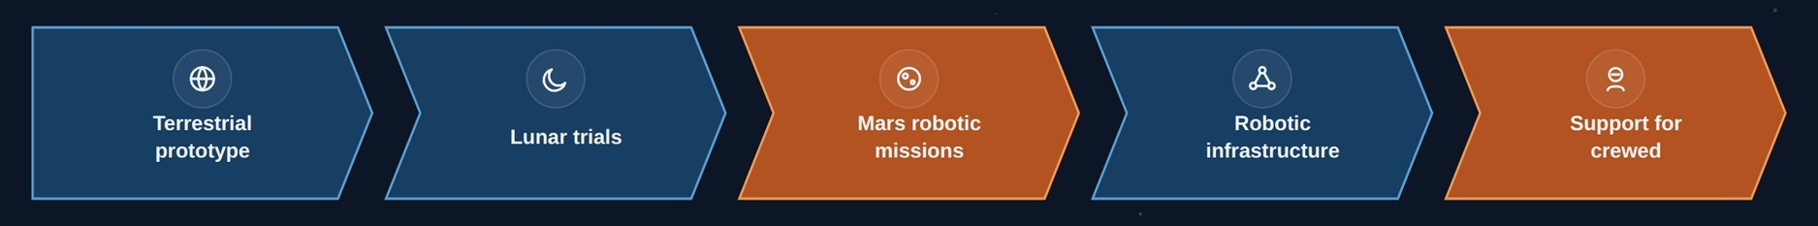 | Fig. 13.1. The development sequence of the Mars Avatar Project architecture

13.5 Presence Technology Beyond Mars
Transferring the architecture to other objects is not a distant fantasy but a direct consequence of its parametric nature:
- the Moon (delay ~1.3 s): the degenerate case — the architecture operates in near-real time; the natural proving ground of Stage II;
- asteroids (minutes to tens of minutes): a regime identical to the Martian one, with microgravity added;
- Europa, Titan (tens of minutes to hours): the limiting case, demanding maximal autonomy; it is here that the accumulated trust statistics (Section 6.4) become decisive.
Each new object requires new platforms (the physical layer) but not a new architecture (the intelligence layer). Herein lies the fundamental economics of the approach: the cost of each subsequent world is lower than that of the previous one, whereas in the crewed paradigm each subsequent world is more expensive.

13.6 A Closing Thought
The history of exploring the world is a history of instruments. Ships made the oceans reachable; aircraft, the continents; computers, the space of thought. Robotic avatars are the next instrument in this line. But their true significance is not that they “fly instead of the human.” It is that, for the first time, the presence of the human mind is separated from the presence of the human body — and therefore ceases to be bound to any single planet. Mars is only the first application. The asset is the technology of presence itself. The future of planetary exploration may depend not only on where humans can travel, but on how effectively human intelligence can be extended through intelligent machines.

Appendix A. References and Literature
Below are the sources supporting the key technical claims of this document. The numbers in square brackets in the chapter text ([1], [2], etc.) refer to the corresponding entries in this list. Reference numbers are assigned by first use within each thematic group rather than sequentially through the document; entries therefore appear out of numerical order below. The list does not claim to be an exhaustive scholarly review and should be regarded as a starting point for further verification.

For Chapter 2. The Challenge of Exploring Mars
[1] ESA, “The radiation showstopper for Mars exploration” — a review of cosmic-radiation risks for long-duration missions, including data from the ExoMars Trace Gas Orbiter and the NASA Twins Study. esa.int
[2] Cucinotta F.A., Kim M.Y., Chappell L., “How Safe Is Safe Enough? Radiation Risk for a Human Mission to Mars,” PLOS ONE, 2013 — a quantitative estimate of the risk of exposure-induced death (REID) for a Mars mission based on the NASA model. Available via PubMed Central (PMC3797711).
[3] Cucinotta F.A., Durante M., “Cancer risk from exposure to galactic cosmic rays: implications for space exploration by human beings,” The Lancet Oncology, 2006, 7: 431–435.
[4] NASA, ASCEND / NTRS, “Communication Delays, Disruptions, and Blackouts for Crewed Mars Missions” — an analysis of communication delay (up to ~22 minutes one way) and periods of complete signal blackout during solar conjunction. ntrs.nasa.gov (20220013418).
[5] ESA, Mars Express Blog, “Time delay between Mars and Earth” — an illustration of the minimum (~3–4 min) and maximum (~22 min) one-way signal delay. blogs.esa.int/mex.

For Chapters 4 and 7. Architecture and Interplanetary Communication
[6] NASA Science, “Mars Relay Network” — a description of the operational network of relay orbiters (Mars Reconnaissance Orbiter, Mars Odyssey, MAVEN, ESA Trace Gas Orbiter, Mars Express) and their role in transmitting data from the Martian surface. science.nasa.gov/mars/mars-relay-network.
[7] NASA/JPL, “The Mars Relay Network Connects Us to NASA’s Martian Explorers” — a technical description of the Deep Space Network and the scheme for relaying commands and telemetry through orbiters. jpl.nasa.gov.

For Chapter 5. Artificial Intelligence and Autonomous Navigation
[8] Verma V. et al., “Autonomous robotics is driving Perseverance rover’s progress on Mars,” Science Robotics, 2023 — data on the share of autonomously driven distance (88% of 17.7 km in the first Martian year) and the records of the AutoNav system. doi.org/10.1126/scirobotics.adi3099.
[9] NASA/JPL, “NASA’s Self-Driving Perseverance Mars Rover ‘Takes the Wheel’” — a description of how AutoNav works: building a 3D terrain map, detecting obstacles, and planning a route without operator involvement. jpl.nasa.gov.

For Chapter 8. Avatar Power Systems
[10] NASA/JPL, “Mars 2020 Perseverance Launch Press Kit — Power” — technical specifications of the MMRTG radioisotope power source (about 110 W at start of life, 14-year design life). jpl.nasa.gov.
[11] Scientific American, “Why NASA’s Perseverance Mars Rover Uses Nuclear Energy” — a comparison of the MMRTG with solar panels and an account of the Opportunity rover, lost to the 2018 dust storm.
[12] Marspedia, “Radioisotope Thermoelectric Generators: Advantages and Disadvantages” — a comparison of radioisotope power sources and solar panels, including the effect of dust devils on the solar arrays of the Spirit and Opportunity rovers.

For Chapter 9. Neural Interfaces (BCI)
[13] Waldert S., “Invasive vs. Non-Invasive Neuronal Signals for Brain-Machine Interfaces: Will One Prevail?”, Frontiers in Neuroscience, 2016 — a comparison of invasive and non-invasive neural-signal acquisition methods by resolution, bandwidth, and risk level. PMC4921501.
[14] “Brain–computer interfaces in 2023–2024,” review article, Brain-X, Wiley, 2025 — an up-to-date review of the accuracy–invasiveness trade-off in modern BCI systems. onlinelibrary.wiley.com.

For Chapter 3. Positioning Relative to Existing Work
[15] ESA, “METERON — Multi-Purpose End-To-End Robotic Operation Network” — an overview of the program of experiments in controlling ground robots from the ISS (2011–2019). esa.int.
[16] ESA, “Analog-1: ESA’s interplanetary teleoperations experiment” — control of the Interact rover from the ISS by astronaut L. Parmitano, November 2019. esa.int.
[17] Schmaus P. et al., “Preliminary Insights From the METERON SUPVIS Justin Space-Robotics Experiment,” IEEE Robotics and Automation Letters, 2018 — supervisory goal-based control of a humanoid robot from orbit.
[18] Oleson S., Landis G. et al., “HERRO: Human Exploration using Real-time Robotic Operations,” NASA Glenn Research Center / AIAA, 2011 — the concept of teleoperating Martian robots from Mars orbit.
[19] Lester D., Thronson H., “Human space exploration and human spaceflight: Latency and the cognitive scale of the universe,” Space Policy, 2011 — an analysis of latency as a key factor in telerobotics.
[20] Bualat M. et al., “Surface Telerobotics: Development and Testing of a Crew-Controlled Planetary Rover System,” NASA Ames / AIAA, 2013–2014 — control of the K10 rover from the ISS.
[21] XPRIZE Foundation, “ANA Avatar XPRIZE” — results of the telepresence avatar-system competition (2018–2022); winner — Team NimbRo, University of Bonn. xprize.org.
[28] Francis R. et al., “AEGIS autonomous targeting for ChemCam on Mars Science Laboratory,” Science Robotics, 2017 — autonomous selection of science targets onboard a Mars rover.
[30] GITAI Inc. — demonstrations of autonomous robotic manipulators on the ISS (S1, 2021; external arm S2, 2024) and development of lunar platforms. gitai.tech.

For Chapter 6. Mission AI Architecture
[26] Muscettola N., Nayak P., Pell B., Williams B., “Remote Agent: to boldly go where no AI system has gone before,” Artificial Intelligence, 1998; flight experiment on Deep Space 1, 1999.
[27] Chien S. et al., “Using Autonomy Flight Software to Improve Science Return on Earth Observing One,” Journal of Aerospace Computing, 2005 — multi-year autonomous operation of the CASPER/ASE planner on the EO-1 satellite.
[29] Choi H.-L., Brunet L., How J.P., “Consensus-Based Decentralized Auctions for Robust Task Allocation,” IEEE Transactions on Robotics, 2009 — the CBBA algorithm for task allocation in multi-robot systems.

For Chapter 11. Quantitative Estimates
[22] Voosen P., “NASA’s Mars Sample Return mission is dead,” Science, January 2026 — cancellation of MSR funding after the cost estimate grew to $11 billion. science.org.
[23] NASA/JPL, “Deep Space Optical Communications (DSOC)” — results of the laser-communication demonstration (2023–2025): 267 Mbit/s at 31 million km; 8.3 Mbit/s at 2.7 AU. jpl.nasa.gov.
[24] NASA, “Kilopower / KRUSTY” — ground testing of a ~1 kWe demonstrator of the 1–10 kWe Kilopower reactor family for space applications, 2018. nasa.gov.
[25] Drake B.G. (ed.), “Human Exploration of Mars Design Reference Architecture 5.0,” NASA-SP-2009-566 — NASA’s reference architecture for a crewed Mars mission.

For Chapter 5. Onboard Computing
[31] NASA/JPL, “Hello Universe: NASA’s Next-Gen Space Processor Undergoes Testing,” May 2026 — the High Performance Spaceflight Computing (HPSC) processor, developed with Microchip Technology under a partnership begun in 2022, entered testing at JPL in February 2026; early results indicate roughly 500× the performance of the radiation-hardened processors currently in flight. The processor is not yet space-qualified and no mission has been announced. nasa.gov.
[32] NASA STMD, “High Performance Spaceflight Computing” — programme description: a fault-tolerant, radiation-hardened-by-design multicore system-on-chip targeting over 100× the capability of current space processors. nasa.gov.

Appendix B. Note on Neural Interfaces
This appendix records the state of brain–computer interfaces for completeness. Nothing in the architecture of this document depends on it (Section 9.3).
A BCI allows signals from the nervous system to be used to interact with a computer. Non-invasive methods — EEG, functional near-infrared spectroscopy, and combined approaches — require no surgery and are safe and accessible, but offer limited accuracy and a low information-transfer rate. Invasive methods place electrodes in neural tissue and offer higher bandwidth, lower latency, and more precise recognition of intent, but remain at the research stage and require further safety evaluation [13][14].
For the Mars Avatar Project the relevant observation is negative: neither branch addresses the constraint that governs this architecture. Interface bandwidth is not what limits an operator working across a delay of minutes. Should neural interfaces mature, they would improve operator comfort at Stage IV and beyond; they would not change what the system can do.

